CURRICULUM VITAE
Dr. P.N. Samuel Saravanan
TUL505 Culture and Language acquisition-I

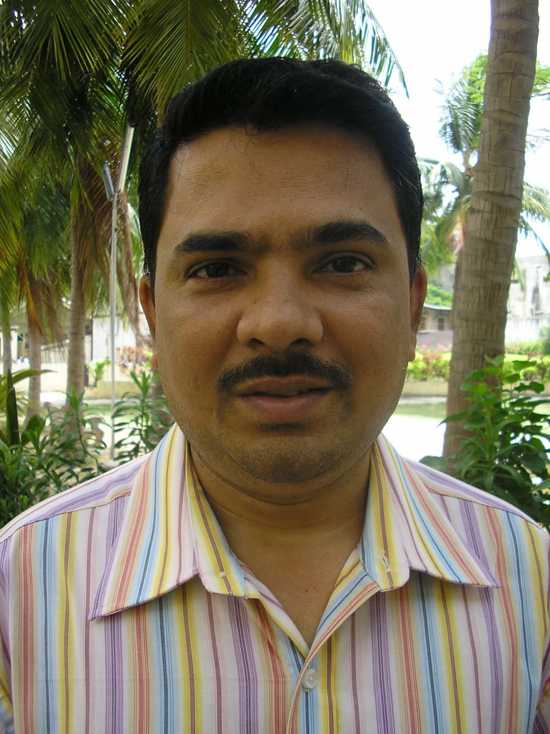

a. Name, age, marital status, children and their age
Samuel Saravanan P.N.
38 years
Married
2 children aged 7&2

b. Position, number of years in this position
MATUL Co-ordinator

c. Degrees earned, year and institution

Degree/Diploma | Institution & the Place | Period of Study (Year)
G.Th | Hindustan Bible Institute & College | 1986-1987
B.Th | Hindustan Bible Institute & College | 1987 - 1990
M.A | Annamalai University | 2000 - 2002
M.Th | Evangelical Theological Seminary of Indonesia | 1993 -1997
Ph.D., | CIME-in collaboration with Fuller, Pasadena | 2002 –2006

d. Teaching field concentration and courses taught
Specialization: Missiology, Anthropology, Sociology
Courses taught: Church Growth and Church Planting, Research Methodology, Urban
Mission, History of Mission, Historical Development of the Church, Biblical theology
of Mission, Introduction to Mission & Anthropology, Evangelism, Church Planting &
Strategies,

e. Number of courses or units taught per year
Minimum 6-8 courses per year

f. Present ministry involvement outside the institution
Pastor, New Calvary Tamil Church, Chennai

g. Status (full-time or part-time): Full time

h. Published works

Articles

- “Church planting among the Javaness in Ambarawa”, Indonesis Alethia, 1995.
- “Indian in Medan, Indonesia”, Pelita Terang, 1996.
- “Tamil Culture in Medan, Indonesia”, Pelita Terang, 1997.
- “Understanding Muslims in Jawa, Indonesia”, Cahaya, 1997.

Journal Articles
- Sourashtrains and their response to Christ – Hindustan Evangelical Review, Vol.1, 2006
- Emerging Mission Theology in the context of religious fundamentalism – Hindustan Evangelical Review, Vol.2, 2007.

Course Manual for B.Th

- Introduction to Christian Ethics

CURRICULUM VITAE
Dr. Varghese Thomas

TUL 520 Urban Spirituality
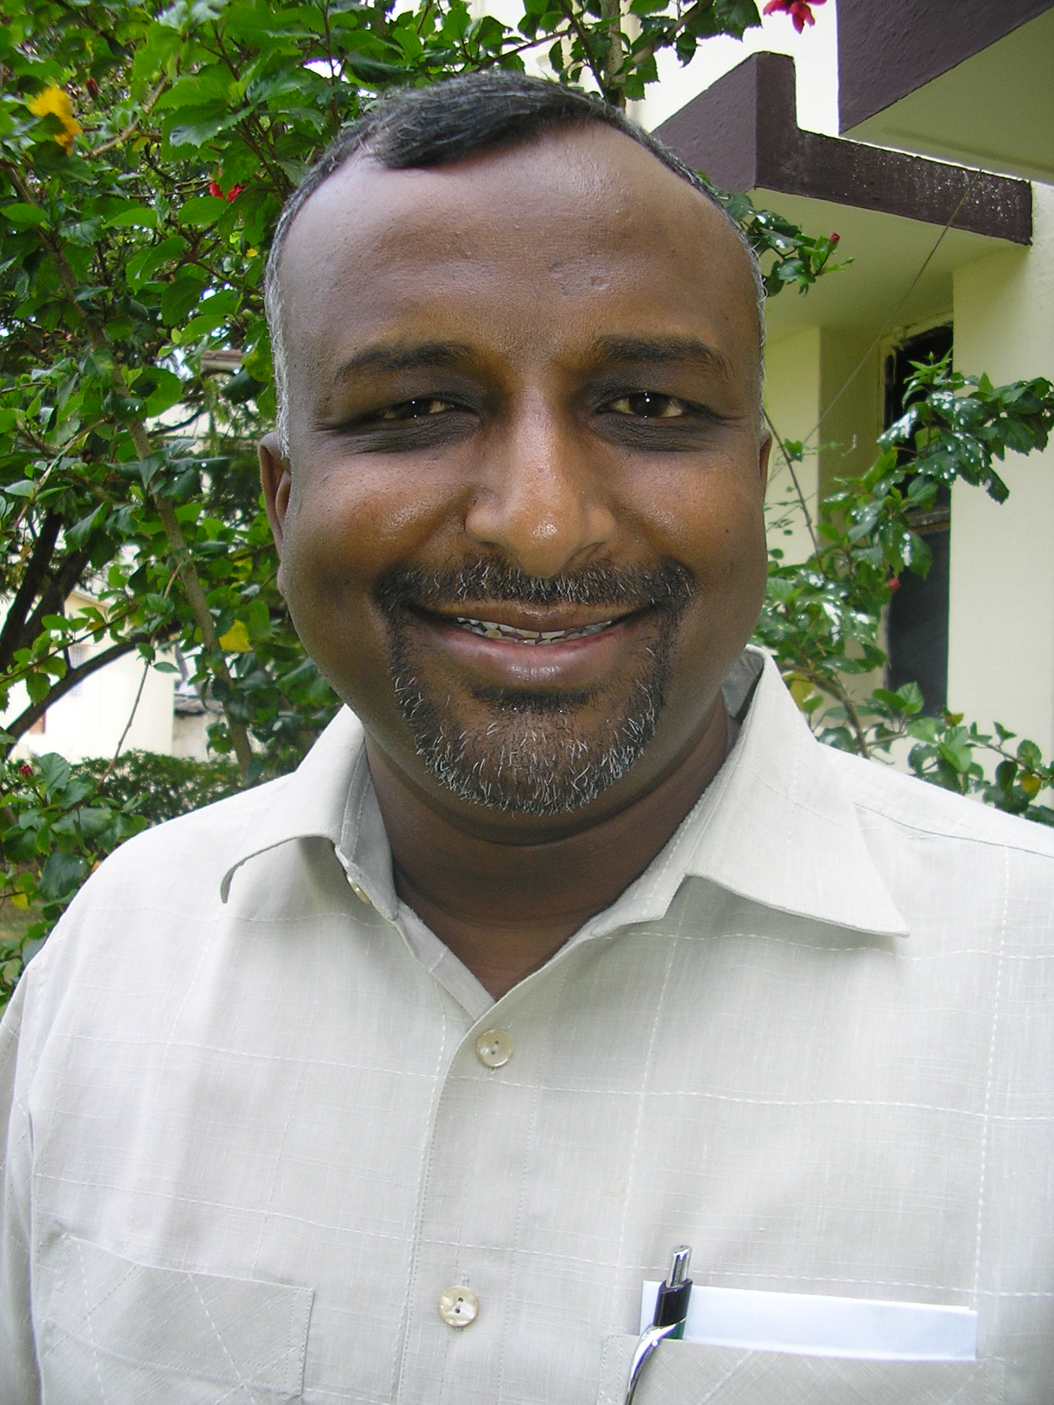
a. Name, age, marital status, children and their age
Varghese Thomas
39 years
Married
2 children aged 12 & 10

b. Position, number of years in this position
Faculty / Director of SF & PC from 2006

c. Degrees earned, year and institution

Degree/Diploma | Institution & the Place | Period of Study (Year)
B.Th | HBI & College, Chennai – 10 | 1986-1989
B.D | Serampore College, Serampore | 1990-1992
M.Th | SAIACS, Bangalore | 1993-1995
Ph.D | Trinity Evangelic Divinity School, Chicago | 2000-2005

d. Teaching field concentration and courses taught
Specialization: Christian Education, Pastoralia, Spirituality
Courses taught: Christian Spirituality, Christian Education, Worship & Homiletics,
Pastoral Care & Counseling,

e. Number of courses or units taught per year
Maximum 6 courses per year

f. Present ministry involvement outside the institution
Pastor, New Calvary Church, INEC, Chennai

g. Status (full-time or part-time): Full time

h. Published works
No. of books published: 2 for B.Th external course
No. of books translated: 3 in Hindi

Journal Articles
- Teachers as Learners: Towards Professional Development through Service Learning - Hindustan Evangelical Review, Vol.1, 2006.

CURRICULUM VITAE
Rev. Jessie Nesakumar

TUL 630 Theology and Practice of Community Transformation

a. Name, age, marital status, children and their age 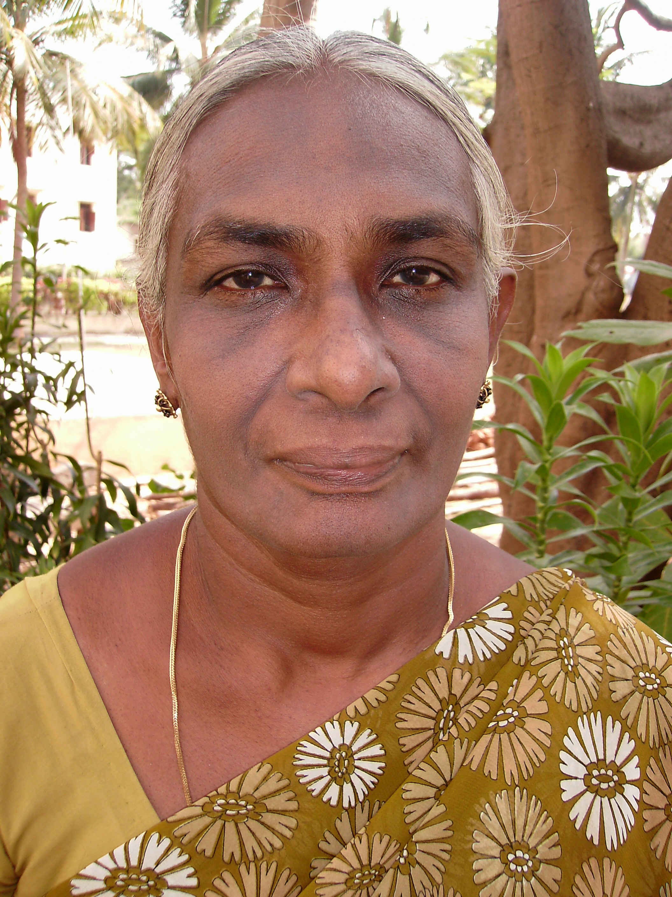
Jessie Nesakumar
56 years
Married
2 children aged 25 & 22

b. Position, number of years in this position
Faculty from February 2007

c. Degrees earned, year and institution

Degree/Diploma | Institution & the Place | Period of Study (Year)
B.A., | Scott Christian College, Nagercoil | 1968 – 1971
B.D. | United Theological College, Bangalore | 1975 – 1978
M.Th. | Tamilnadu Theological Seminary, Madurai | 1987 - 1990

d. Teaching field concentration and courses taught
Specialization: Social Analysis
Courses taught: English, Social Analysis, Understanding Indian Society, theology
&Models of Ministry and Sacraments

e. Number of courses or units taught per year
Minimum 6 courses per year

f. Present ministry involvement outside the institution
Helping the Pastor in the Church (CSI Holy Trinity Church, Korattur)

g. Status (full-time or part-time): Full time
h. Published works
“Envisioning New Heaven and New Earth” - AICCW
CURRICULUM VITAE
TUL650 Primary Health Care 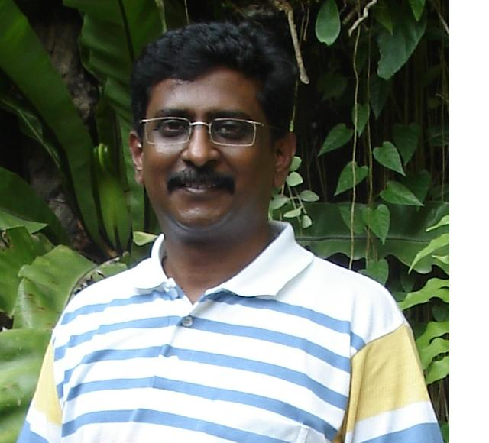
CHRISTOPHER S. BASKERAN
“BETHEL”
No.17, Padma Street,
VGN’s Enclave, Mogappair West, Chennai – 600050 India
Mobile: +91 98407 70203 E-mail: Christopher.Baskeran@gmail.com

Professional Experience
Mar 2008 – till date | National Coordinator – Channels of Hope Programme; and Research and Development Specialist, Models of Learning  World Vision India
Oct 2007 – Feb 2008 | National Coordinator – Channels of Hope Programme
Sep 2005 – Sep 2007 | Programme Manager,  Chennai HIV and AIDS Programme and  Chennai Integrated HIV/AIDS Care (CIHAC) Project,  World Vision India
May 2004 – Aug 2005 | National Coordinator – HIV and AIDS,  World Vision India
Mar 2003 – May 2004 | Coordinator – India HIV and AIDS Initiative,  World Vision India
Mar-2002 – Mar 2003 | Zonal Coordinator – HIV and AIDS &  Vitamin A Add On Program, World Vision India
Oct-2001 – Mar 2002 | Zonal Coordinator – HIV and AIDS,  World Vision India
Dec 1998 – Oct 2001 | Project Manager,  Chennai Integrated HIV/AIDS Care (CIHAC) Project,  World Vision India
Jan 1995 – Nov 1998 | Junior Research Fellow,  (University Grants Commission, New Delhi)  The Madras School of Social Work, Egmore,  Chennai – 600 008
Jan 1996 – May 1997 | Visiting Lecturer,  SCS Kothari Academy for Women,  Kilpauk, Chennai - 600 010
Jan 1994 – May 1995 | Lecturer-in-Social Work,  Madras Christian College,  Tambaram, Chennai - 600 059
Oct 1992 – Oct 1993 | Social Worker,  AIDS Reference & Surveillance Centre,  Indian Council for Medical Research (ICMR),  Dept. of Virology, Christian Medical College & Hospital, Vellore, India.

Technical Skills

Computer | Proficient in MS Office (MS Word, Excel & Power Point); Lotus Notes Communications; MS Internet Explorer
Project Proposals | Skilled in writing proposals for HIV and AIDS Program/Project Implementation; Design, Implementation; Monitoring and Evaluation
Managerial and Leadership | Executing functions; Office Systems and Administration; Coaching and Mentoring Staff; Visioning, Goal Setting and pre-positioning the team; Strategizing and Managing Organizational Change Processes.
Counseling | - Pre and post test counseling for HIV and AIDS Testing;  - HIV and AIDS Care Counseling for PLWHA and their Caregivers  - Bereavement Counseling
Teaching | Proficient in Teaching & Training
Facilitation | Proficient in Facilitation of Group Activities for Planning, Sensitization and Strategizing

Education
Jul 2008 | Doctorate of Philosophy in Social Work,  The Madras School of Social Work, Chennai, University of Madras. India
Sep 2002 | Certificate in Research Design in Qualitative Social Inquiry,  Australian Research Centre in Sex, Health and Society,  La Trobe University, Melbourne. Australia.
Jun 1993 | Qualified in National Education Test for Junior Research Fellowship & Eligibility for Lectureship, University Grants Commission, New Delhi. India.
May 1992 | Master of Arts in Social Work,  Specialized in Medical & Psychiatric Social Work,  Madras Christian College, Tambaram, Chennai, University of Madras. India
May 1990 | Bachelor of Commerce,  Madras Christian College, Tambaram, Chennai, University of Madras. India.

Personal

Age & Date of Birth | 42 years (28-Nov-1966)
Gender | Male
Marital Status | Married
Address – Residence | “Bethel”,  No.17, Padma Street,  VGN’s Enclave, Mogappair West,  Chennai – 600 050. Tamil Nadu, India.  Tel. (H) +91-44 –
Mobile | +91 9840770203
E-mail | christopher.baskeran@gmail.com
Current Employment:  Designation & Address | National Coordinator – Channels of Hope  World Vision India  No. 16, V.O.C. Main Road,  Kodambakkam, Chennai – 600 024.  Tel. +91-44-2480 7174 / 4228 7174  Fax. +91-44-2480 7242 / 4228 7242  Christopher_Baskeran@wvi.org

CURRICULUM VITAE
JEFFREY R. PANKRATZ

TUL 550 Service to the Marginalized
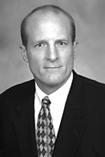
14317 Duvall Hill Court Tel: (91) 9789096829 (India)/ (202) 657-5225 (U.S.A.
Burtonsville, MD 20008 E-mail: jpankratz@justiceventures.org

EXPERIENCE:

2007-Present JUSTICE VENTURES INTERNATIONAL
Washington, D.C. and Chennai, Tamil Nadu, India
President
The mission of Justice Ventures International (JVI) is to secure freedom, justice and restoration for the poor and oppressed by strengthening ventures that protect human rights and promote development.

2000 – 2007 VENABLE LLP
Washington, D.C.
Of Counsel
Practice focused on outsourcing transactions and development finance. Outsourcing and international development finance practice primarily in connection with India where I have lived and worked on and off since 2003. U.S.-based development practice involved real estate equity syndications, community development lending, partnership law, the federal low-income housing tax credit, the new markets tax credit program and other community development programs.

2002 - 2005 INTERNATIONAL JUSTICE MISSION
Washington, D.C. and Chennai, Tamil Nadu, India
Legal Advisor/Pro Bono Counsel
Pro bono legal counsel on matters related to human trafficking and community development. From September 2003 through August 2004 lived in southern India working as legal advisor to the International Justice Mission’s southern India office in Tamil Nadu.

1999 – 2000 THE ENTERPRISE FOUNDATION, INC.
Columbia, Maryland
Director, Management and Organizational Development Division
The Enterprise Foundation provides low-income people with affordable housing, safer streets and access to jobs and child care by facilitating the delivery of loans, grants and technical assistance to nonprofit organizations that are building and revitalizing local neighborhoods in over 860 locations throughout the United States. The Management and Organizational Development Division provides a wide range of organizational development training and technical assistance services to build the capacity of community-based nonprofit corporations, local and state government agencies, and other organizations. Managed national team that worked with Enterprise Foundation field offices to design and deliver training and technical assistance programs in fifteen cities.

1992-1999 COMMUNITY DEVELOPMENT LAW CENTER
Indianapolis, Indiana
Executive Director (and Founder). The Community Development Law Center (formally the Community Organizations Legal Assistance Project) provides pro bono legal and related assistance to community-based nonprofit organizations serving low-income neighborhoods in central Indiana. Assisted numerous community-based organizations with various affordable housing and community development transactions. Recruited and managed panel of over 100 volunteer attorneys and four person staff. Provided training and technical assistance to community groups and volunteer attorneys on wide range of community development law issues.

1998 INDIANA UNIVERSITY SCHOOL OF LAW
Indianapolis, Indiana
Adjunct Faculty. Taught a Seminar in Not-For-Profit Corporations during the fall semester of 1998-99 academic year.

EDUCATION

2005 GEORGETOWN LAW CENTER, Washington, D.C.
Coursework in International Law

- INDIANA UNIVERSITY SCHOOL OF LAW, Bloomington, IN
Juris Doctor, Cum Laude
Moot Court

- CALIFORNIA POLYTECHNIC STATE UNIVERSITY, San Luis Obispo, CA
Bachelor of Science, Business Administration, with Honors

PUBLICATIONS
2002 Section 704(b) Regulations and Tax Credit Transactions: Structuring Low-Income Housing Tax Credit Transactions to Avoid Reallocations of Tax Credits and Losses,, (co-author) American Bar Association Journal on Affordable Housing and Community Development Law

2001 IRS Rulings May Significantly Reduce Eligible Basis in Tax Credit Transactions, (co-author) American Bar Association Journal on Affordable Housing and Community Development Law

- Meeting the Legal Needs of Community-Based Development Organizations, American Bar Association, Division for Public Service Monograph Series

- Neutral Principles and the Right to Neutral Access to the Courts, 67 Indiana Law Journal 1091

SELECTED AWARDS AND APPOINTMENTS

2004 Distinguished Service Award, Indiana University School of Law, Bloomington
2003 Editorial Board, ABA Journal of Affordable Housing & Community
Development Law
2003 Benjamin R. Civiletti Pro Bono Lawyer of the Year Award
1999 Staff of the Year, Presented by the Indiana Association for Community
Economic Development
- Pro Bono Publico Award, Presented by the Indiana Bar Foundation
1995 Co-Chair of the IOLTA Pro Bono Committee, Appointed by the Chief Justice of the Indiana Supreme Court. The Committee produced a statewide pro bono plan and drafted a new Indiana Rule of Professional Conduct 6.5 that was subsequently enacted by the Indiana Supreme Court

BAR ADMISSION

- Admitted to the Indiana Bar.
- Admitted to the District of Columbia Bar and the Maryland Bar.

CURRICULUM VITAE
p. paul ebenezar
TUL 530 Urban Poor Church Planting

objective
To serve the body of Christ in imparting Christian Values and Knowledge and to equip ministers and leaders for extension of the kingdom of God.
Research Experience
- March – April 2007 was involved in a research in partial fulfillment of a the subject, Communication and Writing Skills of the M.A. course in Journalism and Mass Communication of the Madurai Kamaraj University and was titled as, “Status and Portrayal of Women in Mass Media and its impact on Kannagi Nagar Slum, Chennai”.
- June 2004– March 2007 was involved in a research for the award of M. Phil Degree in Sociology from Madurai Kamaraj University and the dissertation was titled as, “Occupation and Expenditure Patterns of Slum Dwellers – A Study with Particular Reference to the Kannagi Nagar Slum, Chennai”.
- June 2001- April 2002 was involved in a research work for the award of Master of Theology (M.Th.) in Missiology from the Hindustan Bible College, Chennai and was titled as, “Church Planting and Church Growth among Slum Dwellers with particular reference to Adambakkam Slum, Chennai”.
TEACHING EXPERIENCE
- June 2001- April 2008 served as lecturer, Mission coordinator and as Academic Dean in Antioch Bible Seminary affiliated to Asian Theological Association (ATA), handling diverse subjects such as Church History (Early, Medieval, Reformation and Modern and Indian Christian History), Missions, Missionary Anthropology, Christian Education, Communication, Homiletics, Theology, and Introduction to Indian Society.
- June 2000- March 2001 served as Guest Faculty in SISWA Bible School handling subjects such as Homiletics and pastoral Theology.
Education
- 2006- 2008 M.A. in Journalism and Mass Communication from Madurai Kamaraj University with First Class.
- 2005-2007 M.A. in Philosophy and Religion from Madurai Kamaraj University.
- 2003- 2005 M.Phil in Sociology from Madurai Kamaraj University with First Class.
- 2001 – 2003 M. A. in Sociology from Annamalai University.
- 2001- 2003 M.Th in Missiology from Hindustan Bible Institute affiliated with Asia Theological Association with A+.
- 1998 – 2000 B.D from Bharath Bible College, Hyderabad with A+.
- 1995-1998 B.Th from Maranatha Bible Institute and College with First Class.
Ministerial and Pastoral Experience
- Pioneered and established a weekly fellowship for the Cab drivers from 2000- 2003.
- Served as Pastor in Charge of the Advent Christian Assembly in Sriperumbudur from 2004-2005.
- Serving as Pastor in charge of the Advent Christian Assembly, Ponmar from 2005 – till date.
SKILLS AND GIFTS
- Skilled at Puppetry, Flannel Graph presentation and other creative tools used in Children’s ministry.
- Skilled at Interpretation from English to Tamil
BIOGRAPHICAL INFORMATION
- Born on 26.10.1977
- Languages Known: Tamil and English
- Residing at : # 5, ESIC Nagar, Rajiv Gandhi Cross Street, Thiruvencherry, Chennai – 600073.
- Contact Details:
Mobile: +91 9444801350
Residence: 044- 22290472
Email id’s: paulebi77@yahoo.co.in

CURRICULUM VITAE
Fr. Dr. Rosario Gomez

TUL555 Education Centre Development

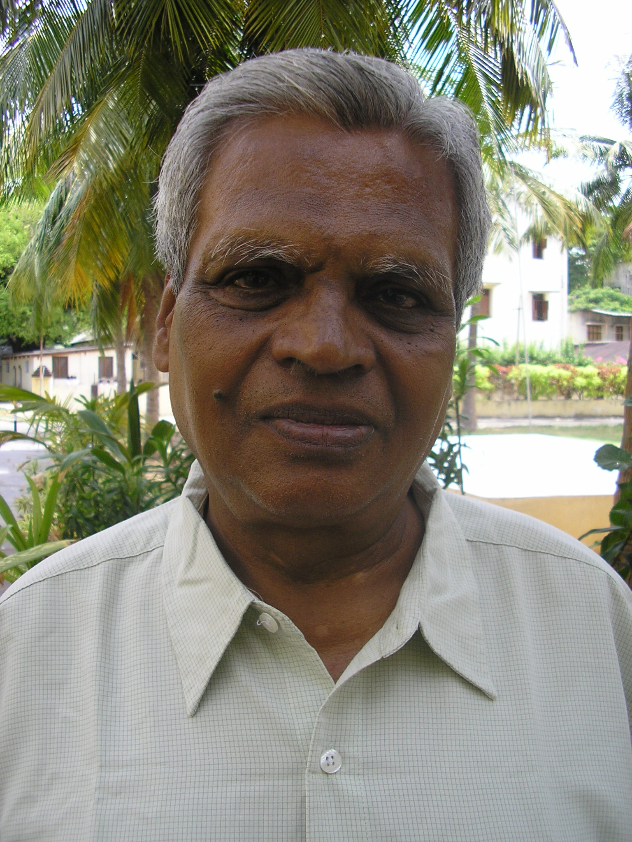

Rosario Gomez (1937) is a Teacher, Priest and a Scholar. To become a Teacher, he obtained degrees of Bachelor of Science (B.Sc.) and Bachelor of Teaching (B.T.). To become a Priest, he underwent three years of Philosophical Studies and four years of Theological Studies and earned degrees of Licentiate in Philosophy (L.Ph.) and Licentiate in Theology (L.Th.). He did his L.Th. in Frankfurt on the Main in Germany. To become a Scholar he obtained a Ph.D. studying Communication and Pedagogy and specializing in Development Communication in the Westphalian Williams University in the German town of Muenster.

Since he returned to India after his studies abroad in 1974, he has served the nation in various capacities. He was

 Secretary to the Commission on Social Communication of the Tamilnadu Bishops' Conference (1974-1975),
 First-Director of the State Resource Centre for Non-formal Education of the State of Tamilnadu (1977-1985).
 Founded his own institute called Indian Institute of Non-formal Education in 1986 and while he was struggling hard to develop it, he was invited to Delhi to assist in the Directorate of Adult Education, Government of India, as a
 Consultant Training in its National Literacy Mission (1988-1991). When he came back to the State after that assignment, he was made
 Course Co-ordinator for the Two Year Diploma in Rural Development Management run by the Centre for Research on New International Economic Order (CReNIEO), Chennai (1991-1995).

In 1986, he helped Gurukul Lutheran Theological College and Research Institute at Chennai to develop the curriculum and the course material for a course on the Theology of Human Development. Since then till date he is teaching that subject to Bachelor of Divinity (B.D.) students. He was made the Convenor of the 10 days long Summer Institute of Gurukul Theological College in 1997 on the theme of Theology of Human Development. He collected all the papers presented in that institute, edited and put them together in a book Towards a Theology of Human Development (1998). In 1995, when Gurukul Theological College started offering Masters degree in Theology (M.Th.) in Communication, he was invited to serve there as of Professor of Communication and was promoted to head, the Department of Communication in the same college from June 2001.

As a Development Educationist, Trainer and Consultant, he goes round the whole country offering his services to the Central and State Governments, NGOs, Overseas Funding Agencies and different churches. During his tenure as Consultant (Training) in the National Literacy Mission of the Government of India, the Principal Regional Office for Asia and Pacific (PROAP) of the UNESCO at Bangkok trained and utilised him as a Resource Person for the Training of Adult Literacy Personnel in its member states of India, Thailand, Nepal and Bangladesh.

In all these years, as a Scholar, he has combined Teaching/Training with Research and Extension. Every year he has been personally taking up one or two evaluation studies. Besides, he has guided others in such studies. Since 1992, he has been guiding at least one student every year in their theses that are required for their PG Diploma or Degree. Since 2001, he is also guiding a candidate for D. Th. in Communication in Gurukul Lutheran Theological College and Research Institute.

He has co-authored three Training Manuals in Participatory Training: one for the
Adult Education Functionaries, one for the Non-formal Education Functionaries and a third for the Training of Small Building Contractors who are either illiterate or semi-literate. He has published and still goes on publishing in Theological and Adult Education Journals many articles on Adult Education, Non-formal Education and Development Communication.

Chennai, 11. 09. 2003 (R. Gomez)

CURRICULUM VITAE
LILIYAN SWARNA KALAI (49)

TUL 655 Advocacy and Urban Environment

MAILING ADDRESS 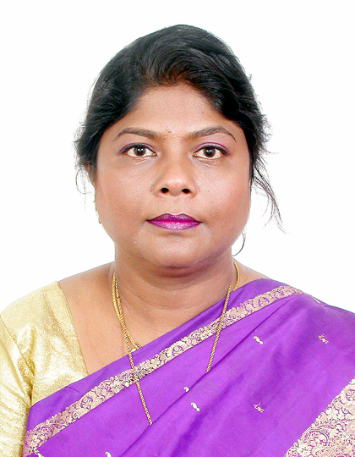

‘Manuel Manse’, No. 9, II Street
North Jaganatha Nagar Annexe
Villivakkam, Chennai – 600 049.

Phone: 2650 0083
Mobile: 94442 23550

PRESENT POSITION

Community Officer
Chennai Metropolitan Development Authority (CMDA)
Thalamuthu-Natarasan Buildings

No.1, Gandhi-Irwin Road

Egmore, Chennai-600 008.

EDUCATION

- B.A. Degree (English Literature) from Madras Christian College, 1976-79

- M.A. Degree (Social Work) from Madras School of Social Work, 1979-81

Ph.D. Scholar, Sacred Heart College, Thirupathur. Submitted the Thesis titled “Community Involvement in Community Based Environment Development Programme in Sustainable Chennai Project” in partial fulfillment for awarding degree in Doctor of Philosophy in November 2007, University of Madras.

LANGUAGE KNOWN
Tamil (Read, Write and Speak)
English (Read, Write and Speak)
Malayalam (Understand)

PROFESSIONAL EXPERIENCE

- Environment Educator in Spastic Society of Tamil Nadu, January 1982-April1984.
- Community Officer in CMDA from May1984 till date.
SKILLS
- Computer knowledge – MS office (Word, Excel, Power Point)
- Public Speaking, Public relations
- Negotiation, Motivation, Co-ordination, Community Organization, Counseling
- Report writing, Formulating project proposals, Exposure in mass media
- Anchoring programs

COUNTRIES VISITED – Singapore, Italy and Hawaii

OTHER ACTIVITIES

- School Pupil Leader in Christ King Girls’ High School, Tambaram (1974 - 75)
- President Girl Guide, 1975 (Bharat Scout and Guide Movement)
- Represented the School and College in Athletics and Volley Ball
- College Representative for Pre-University classes in Srimathi Dev Kunwar Nanalal Bhat Vaishnav College for Women, Chromepet, (1975 -76)
- Treasurer-Students’ Union in Madras School of Social Work, Egmore (1980 - 81)
- Member, Advisory Committee, CSI St. Stephen’s Church, Villivakkam (1999 - 2005)
- Pastorate Committee member, St. Stephen’s Church from April 2005

PUBLICATIONS
- Articles, poems and short stories in college magazines
- Article on Community initiatives in the journal of the Institute of Town Planners India. (September 2002)
- Paper on “Urban issues & sustainable planning in Chennai city” in the book of abstracts, Eco conference 2003 organized by Eco Vision Department CSI Madras Diocese (November 2003)
- Paper on “CMDA – Community Based Environment Development Program” in the Compendium of Articles for World Habitat Day 2004, organized by the UN – HABITAT, Chennai (India). (October 2004)
- Co-authored a paper on “Meaningful participation in Urban Housing & Environment” in the Seminar on New forms of governance in Indian mega cities organized by Center for the study of regional development, School of social sciences, Jawaharlal Nehru University (January 2005)

PAPER PRESENTATIONS
- New forms of governance in Indian mega cities: Issues concerning partnership. Presented at a conference organized by the Madras School of Economics on 22nd November 2003
- Urban issues and sustainable planning in Chennai city. Presented and published at the Eco conference 2003 organized by the Eco Vision Department, CSI Madras Diocese on 28 November 2003.
- Effective Participation. Presented to the Vice-Chairperson & Member-Secretary/CMDA, Director of Town Panchayat, Commissioners of Municipalities and Executive Officers of Town Panchayats within the Chennai Metropolitan Area on 16th March 2004.
- Best Practices adopted in Hyderabad Urban Development Authority & Municipal Corporation of Hyderabad based on the visits made. The presentation was made to the Vice-Chairperson & Member-Secretary and the Senior Officers / CMDA
- Meaningful participation in Urban Housing & Environment. Made a PPT presentation at the Seminar on New forms of governance in Indian mega cities organized by Center for the study of regional development, School of social sciences, Jawaharlal Nehru University (January 2005)
EVANGELICAL TRAINING
Attended “Advanced Leadership Seminar” at the Haggai Institute Mid-Pacific Center, Maui during the period January 10 – February 3. 2006.
The subjects dealt with during the course were:
- Biblical Mandate for Evangelism
- Goal Setting
- Biblical and Contemporary Methods of Evangelism
- Our Goal: To bring Jesus to Everyone in the World
- The Use of Audio-Visuals in Evangelism
- Effective Communication
- Role of Christian Women in Evangelism
- Christian Leader and Integrity
- Motivating, Mobilising and Training Leaders for Evangelism
- Youth Evangelism

CURRICULUM VITAE
I.JASMINE LYDIA
TUL560 Theology and Practice of community Economics

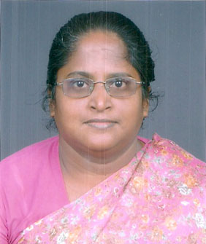
Name : I.JASMINE LYDIA
Date of Birth : 19. 03 1965
Age : 40 Years
Nationality : Indian
Religion : Christian
Marital Status : Married
State of Domicile : India
Permanent Address : 47/2 Paddy field Street Perambur, Chennai 600 011
Tamil Nadu, India
Telephone : 91-(044)-26620212
E.mail ID : pioneert65@hotmail.com
Pioneert65@gmail.com
Language known : English: Read & Write
Indian Languages

Educational Qualification
Sl. No | Degree | College / University | Subject (Major) | Division Class
1 | B.A. | Women’s Christian College  University of Madras | History 1983 – 86 | II
2 | M.A | Stella Maris College  University of Madras | Social Work 1988-90 | I
3 | M.Phil | Loyola college  University of Madras | Social Work 1993 – 97 | II
4 | Ph. D | Madras University | Sociology  1997-2005 | Completed as  Out standing
Work Experience
S. No. | Organization | Duration | Position held | Nature of work
1. | Dalit Education Libration Centre | 1986 to 1988 | Community organizer | Organized women’s associations  Organized leadership and skill training for the women  Assisted in orphanage works. Organized medical camps and special events for the children. Focused on tuition (special coaching) for the children.
2. | World Vision of India | 1990 to 1992 | Project Manager | Worked in a resettlement area.  The resettlement area needed more attention.  Implemented various development activities such as health centre, crèches, and formed women’s associations.  Organized awareness programmes.  During the time of flood, flood relief was done for the affected families in the community with Government partnership
3. | Slum Women Advancement project | 1992 to 1997 | Women coordinator | Worked in a resettlement area. In this place made liaison work between government and the NGO for construction of houses for 3,000 families in the resettlement community.  Focused on economic empowerment of women through SHG’s( self help groups).
4. PIONEER TRAD -since 1997 been functioning as its Director, the chief
functionary.
Nature of work
GOVERNMENT PROJECTS
Implemented various welfare schemes in collaboration with the government departments.
State Social Welfare Board
Launched condensed course for the girls (failed 10th standard students) gave special coaching and enabled them to appear for the public examination. These girls are from the sub- altern communities, in the absence of this programme these girls would have ended up as domestic maid servants, now with further training in paramedical courses they are employed in hospitals etc.
Ministry of Environment & Forest
Conducted National Environmental / Awareness Campaign from 1998 to 2004.
- Conducted environmental awareness programmes on water pollution and health hazard, importance of tree planting and the importance of clean environment.
- Organised environmental exhibition and conducted the drawing competition for the school students on the theme on clean environment.
- In two government schools installed smokeless chulah and distributed 1,000 tree saplings to 1,000 familes.
Ministry of Health and Family Welfare
Conducted Health Programmes
- Reproductive Track Infection (RTI) project has been implemented this had identified nearly 225 women with the RTI problems. Through this project conducted periodical medical camp, health awareness, and referrd the patients to government hospitals.
- Child Care project (0 – 5 years): Under this project we have covered 1,000 children. Identified low-birth weight children, immunization awareness was given, through this project low-cost nutrition awareness and demonstration classes have been conducted for the mothers. Under this project children were given vitamin A & de-worming tablets.
D.Tamil Nadu Women Development Corporation
Through this project Self-Help Group (SHG) was formed, Nearly 745 SHGs was formed in two panchayats.
Formed Self-Help Group (SHG) and focused on the following
- SHG leaders training (3 levels of training)
- SHG members training (4 levels of training)
- Linkage of SHG with nationalized bank for loan.
- Provided Business Development Service training to the women (BDS)
- Provided skill training to women to start small business.
- Formation of panchayat level federation.
- Work with local authorities / bodies and enabled the women to get the welfare scheme.
- Tamil Nadu Pollution Control Board
Evaluated a government project on green land. This is the radio broad casting programme on every Sunday at 3pm to 4pm. The environmental group has been formed in all the districts of South India. These environmental groups will listen to the radio broadcast. The various environmental related issues will be discussed. After listening to this, the environmental group will teach the community.
The evaluation was conducted on how this programme was useful and how this programme can be upgraded and what are the difficulties and problem face by the environmental group in teaching to the community.
F.National Development Agency:- Government of India
- Helping the communities with limited access to technology to realize their potential
- Fostering entreprenenship in rural areas among the youth.
Focusing on the above objective implemented Para-Medical training.
The Para-Medical training:
- Female Nursing Assistant (FNA) – (one year)
- Diploma in First-Aid and Practical Nursing – (two years)
- Diploma in Medical Laboratory Technician (DMLT) – (one year)
- MRI & CT Scan course – (one year)
II. UNCHS- Chennai chapter
3 years conducted and organized programme on world habitat day.
- Conducted Awareness programme for women and children
- Conducted competition among the school children.
III. SEVA BHARAT- Mission India
Adult Literacy project. Through this project identified 500 illiterate women. Conducted literacy classes. This enable the women to become neo-literate.
Through this project the following are conducted
- Health awareness programme in 5 villages
- 2 medical camps
- Social awareness programme in 5 villages &
- Income generation training in 5 villages.
IV. Consultant for the (operational mobilization in the state of Orissa and in the state Manipur, India).
In this consultancy services provided technical assistance and contributed to the development, planning, implementation of the work plan.
V. Member of Micro-Credit summit campaign Washington D.C.
- Attended the international summit held Delhi 1999 and in Bangladesh 2002.
- Every year we will send our Institutional Action Plan (IAP) to the Asia pacific co-ordinator.
VI. Member of Sa-Dhan Network
Provide on active role in the Sa-Dhan network. Involved with three in house thematic sub-groups like a) Policy
b) Capacity Building and c) Standard.
Attended the policy level meeting on the Micro Financial sector (Development and Regulation) bill 2007 introduced in the parliament on March 20th 2007 and later referred to parliamentary standing committee (finance). Sa-Dhan since its inception has been involved on the need to have a facilitating regulatory frame work that address the legal, regulatory and development concerns of micro finance sector in India.
VII. Involved in the state level consultative work shop on status of children without parental care and lesson learned in the context of Tsunami, organized by Tamil Nadu Tsunami Resource Centre (TNTRC) & NGO Co-ordination and Resource Centre (NCRC) in association with the child protection care group at TNTRC, UNICEF, save the children, ICCW, child line, child secretariat.
We have involved in the Tsunami permanent and immediate relief work. Presently I am with the permanent relief work, we are assisting the children (became widow during Tsunami) with educational support and monthly provision supply for the 10 widows.
VIII. Presently I am also involved in the curriculum preparation and teaching the subject on community economics at thhe Hindustan Bible Institute & college, India in the M. A in Transformational Urban leadership training program.
IX. I am also functioning as an honorary committee member of District level co-ordination committee at collectorate office of Government of Tamil Nadu and social action committee of Church Auxiliary for Social Action(CASA).
As a Director of PIONEER TRAD since 1997 I also had to play the following roles to my delight:
I played a role of a coach, mentor and evaluated the staff. Participated in recruitment, selection & training of new staff.
Provided consultancy services, In this gave technical assistance and oversee and take the necessary action to ensure smooth execution of field project.
Coordinated and facilitated with the social development stake holders. E.g. governments, local authorities UN, research institutes and international organization.
The implementation of various projects has contributed to the development, planning and implementation of work plans and budgets. Similarly carry out and supervise the programme activities was also done.
Regular staff meeting will be held with all the department will plan and allocate work assignment.

Seminars, Symposia and Workshop Attended
Sl. No | Name of the Programme | Duration | Capacity | India / Abroad
1 | Global warming and Local promise | 3 weeks | Participant | U.K
2 | Micro-Credit training | 2 weeks | Participant | Bangkok
3 | Micro-Credit & Small | 2 Weeks | Participant | Nairobi
4 | Health Scheme | 3 Days | Participant | Chennai
5 | Economic Development Training | 1 week | Participant | Chennaii
6 | Credit plus health education  (Freedom from hunger materials) | 1 Week | Participant | Chennai
7 | Self-Help Group training (Group members training, leaders training, BDS training, panchayat training) | 1 Week | Participant | Chennai
8. | Panchayat Level Federation training | 1 Week | Participant | Chennai
Research
Sl. No | TOPIC | INSTITUTE | SUBMITTED TO & for
1 | water pollution and health hazard  (KAP – Study) | Loyola College | Madras University  M. Phil degree
2 | Natural resource Degradation and firewood crises | Madras University | Madras University  Ph. D Degree
3 | Job satisfaction of social worker in the community development setting | Stella Maris college | Madras University  M. A degree
Published Work
Sl. No | TITLE | IINSTITUTE
1 | Water pollution and health hazard | ISPCK
Three References
1.Dr. D.S. K. Rao
South Asia Organiser
Micro-credit summit, Washington D.C
dskrao@yahoo.com, dskrao@satyam.net.in
2. T. Vasantha Kumar ph.d
Professor and Head
Department of Geography
University of Madras
thangavelukimaran@gmail.com
3. karupppiah, Ph.d
Professor and Head
Department of Sociology
University of Madras
Chennai
akaruppiah2002@yahoo.co.in

Declaration
To the best of my knowledge and conscience that the facts mentioned above are true to the nest of my satisfaction, hence I hold complete responsibility

Place :
Date : (Dr. I JASMINE LYDIA)

CURRICULUM VITAE
Rev. Dr. J.N. Manokaran

TUL540 Urban Reality & Theology
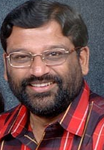

G. GLADSTON XAVIER

CAREER OBJECTIVE : To work with a daring and creative spirit, asserting life openly, relating
to the world with a realistic hope to instill humanism in humanity.

Date of Birth : 23.10.1975

Address for Communication Lecturer
Department of Social Work
Loyola College
Chennai
Phone 94440 53063
e-mail gladstonxavier@gmail.com

Major Fields of work
Conflict transformation, Advocacy, Refugees and displaced, Trauma healing, Theatre, Dalits, Adult education and People Living with HIV/AIDS.

Major areas of work
Community Development, Community based conflict transformation, Research (qualitative and quantitative), Process documentation, Institutional re-visioning, Designing social audits, Planning and implementing disaster response, Conducting assessments

Major areas of training
Peace building and Conflict transformation, Participatory Qualitative Research, Developing tools for assessment, Proposal writing, Log Frame Analysis, Participatory Learning Assessment, Counseling, Trauma Counseling, Playback Theatre, Forum Theatre, Strategic planning, Negotiation, Conflict frameworks and analysis, Curriculum development for Peace education, Scaling up, Communication and leadership, Dialogue training.

Employment Experience

Department of Social Work, Loyola College, Chennai - Since December 2000

Lecturer
Teaching in the post graduate department,
Specialization: Welfare of the weaker sections Comprising of Women, Children, Dalits and Refugees/migrants, Human Rights and Social Work practice
Associate lecturer for Social Work history and philosophy, Community Organization and Research Methodology
Principal Investigator
Loyola Institute for Industrial, Organizational and Social Science Research
Staff-In-charge
UG and PG Community Outreach Programs
Coordinator
The Refugee Project, Capacity building of Sri Lankan Refugees

Organization for Eelam Refugee Rehabilitation (OfERR) - Since 1998
Technical Support
Assignment: Working in the advocacy and human resources development section on National and International advocacy on peace building, refugee rights capacity building and training of refugees and grass roots communities.

YRG CARE- Horizons Project - February 2000-December 2000
Research Associate
Assignment: Operations research, scaling up project creating a base line document and base model documents, documenting the process of progress of the project.

Department of Social Work Loyola College, Chennai - September ‘99 to Feb 2000
Research Associate for Human Rights
Assignment Developing a Curriculum on Human Rights for Masters Level

End Child Prostitution in Asian Tourism (ECPAT) - July – September 1999 (Project Period)

Project Associate
Assignment Campaign Network Building among the child rights groups in South India. Building a research body to document the child prostitution cases

Projects and programs undertaken in the capacity of a Consultant

Agency: OfERR(Ceylon)
Responsibility: Peacebuilding and intercultural workshops with Hindu, Muslim, Buddhist and Christian Communities
Period: May 2008

Agency: Dan Church Aid
Responsibility: Evaluation of SWOAD programs
Period: May-June 2008

Agency: OfERR(Ceylon)
Responsibility: Documentary filming on Success stories of Resilience
Period: March 2008

Agency: OfERR(Ceylon)
Responsibility: Needs Assessment of Resettled IDPS in Eastern Sri Lanka
Period: January 2008

Agency: Dan Church Aid
Responsibility: Evaluation of Sewa Lanka Batti and Ampara Livelihood Projects
Period: October 2007

Agency: OfERR(Ceylon)
Responsibility: Peacebuilding Training for OfERR Staff - Mannar, Trincomalee and Batticaloa
Period: May 2007

Agency: USEFI (Chennai)
Responsibility: Peacebuilding workshop to train school teachers - Chennai
Period: March 2007

Agency: OfERR(Ceylon)
Responsibility: Needs Assessment in Sri Lanka- Mannar, Trincomalee, Batticaloa and Vavuniya
Period: December 2006

Agency: Dan Church Aid (DCA)
Responsibility: Evaluation of DCA-OfERR projects in Sri Lanka- Mannar, Trincomalee, Batticaloa and Vavuniya
Period: December 2006

Agency: OfERR(Ceylon)
Responsibility: Livelihood study in Sri Lanka- Mannar, Trincomalee, Batticaloa and Vavuniya
Period: November 2006

Agency: OfERR(Ceylon)
Responsibility: Exploring safe zones and internal flight alternatives in Sri Lanka- Mannar, Trincomalee, Batticaloa and Vavuniya
Period: April-June 2006

Agency: OfERR(Ceylon)
Responsibility: Conflict transformation training in Sri Lanka
Period: May-June 2006

Agency: Organization for Eelam Refugee Rehabilitation (India)
Responsibility: Study the perceptions of the Sri Lankan refugee about return to Sri lanka
Period: December 2005-June 2006

Agency: OfERR (India)
Responsibility: Assessment of the situation of newly arriving refugees in India from Sri lanka
Period: May 2006

Agency: Pakistan Community Development program
Responsibility: Training on Trauma Healing for the earthquake affected people
Period: 8th May 2006

Agency: Rawalpindi Eye Donors Organization (REDO) - disaster relief team
Responsibility: Introduction to trauma and its impact in times of disasters
Period: 9th May 2006

Agency: Interactive Resource Centre
Responsibility: Training on theatre for trauma healing
Period: 10th - 15th May 2006

Agency: The Henry Martyn Institute, Hyderabad

Responsibility: Conflict Transformation and inter-religious dialogue

Period: 21st May 2006

Agency: The Henry Martyn Institute, Hyderabad

Responsibility: Theatre and Trauma healing for community volunteers from all parts of India

Period: January 2006

Agency: The Henry Martyn Institute, Dimapur

Responsibility: Peace and Conflict transformation training for Naga Leaders
Period: January 2006

Agency: The Henry Martyn Institute, Hyderabad

Responsibility: Facilitation Training for Post graduate students in Conflict transformation
Period: December 2005

Agency: The Henry Martyn Institute, Hyderabad

Responsibility: Mediation and Trauma healing process for Senior Baptist Church Officials
Period: November 2005

Agency: Danish Church Aid, Copenhagen

Responsibility: Housing needs assessment for Rebuilding North and Eastern areas of Sri Lanka
Period: November 2005

Agency: Christian Aid and OfERR Sri Lanka

Responsibility: Study on the equity issues in post -Tsunami reconstruction
Period: October – November 2005

Agency: The Henry Martyn Institute, Hyderabad

Responsibility: Trauma healing Workshop for the 1st semi Annual Workshop July 2005
Period: August 2005

Agency: APAC

Responsibility: Designing Process documentation tools for community based care and support in four districts
Period: since June 2005

Agency: Organization for Eelam Refugee Rehabilitation India

Responsibility: Designing and Conducting peace building trainings for refugees
Period: 26^{th-} 28th April 2005

Agency: Organization for Eelam Refugee Rehabilitation India

Responsibility: Designing and monitoring a Psycho-social intervention for Tsunami Victims in Nagapattinam and Cuddalore.
Period: Since January 2005

Agency: Organization for Eelam Refugee Rehabilitation India

Responsibility: Developing a peace-building dialogue in Sri Lanka
Period: Since February 2005

Agency: Organization for Eelam Refugee Rehabilitation Ceylon

Responsibility: Conducting Training of trainers, Facilitate training by trainers in qualitative research and counseling

Period: 2nd Feb 2005- 10th Feb 2005

Agency: Conflict Management Group/Mercy Corps, Boston USA

Responsibility: Designing across cultural training module
Period: September 2004 to November 2004

Agency: Academy for Educational Development(AED) Center for civil society and governance, Washington D.C USA

Responsibility: Designing an interactive online theatre module, supporting the South Asia Projects, Backstopping support in proposal writing.
Period: May 2004-July2004

Agency: Family Health International

Responsibility: Research associate, Assisting in conducting qualitative research training for needs assessment of Migrants to spread Behaviour Change Communication
Period: April June 2003

Agency: Organization for Eelam Refugee Rehabilitation

Responsibility: Conduct participatory qualitative needs assessment of internally displaced people living in camps in Sri Lanka
Period: MAY 2003

Agency: UNAIDS

Responsibility: Assisting the state of Madhya Pradesh in strategic planning for three years to deal with HIV/AIDS
Period: May 2002

Agency: Organization for Eelam Refugee and Rehabilitation (OFERR)
Responsibility: Training of refugees and migrants in counseling
Since: June 2002

Agency: NACO
Responsibility: Assisted in developing the proposal for the Global Fund (HIV Section) In the area of inclusion of NGOS in providing care

Agency: Karnataka consortium of PMTCT
Responsibility: Writing a proposal for the consortium of four organizations and strategic planning for three years
Period: February 2002

Agency: Elizabeth Glazer pediatric AIDS Foundation/Asha Kirana
Responsibility: Documentation of Proposal writing workshop
Period: 6-10 January 2002

Agency: UNDP, GIPA, South Asian program.
Responsibility: Evaluation monitoring and reporting the process and the GIPA project for South Asia.
Period: May 2001- Dec 2001

Agency: Action Aid India
Project: Evaluation of Self Help Groups, conducting a feasibility study for Income generating programs in Mettur District.
Period: Aug 2001

Agency: YRG CARE
Project: Horizons Project (Population Council – HIV/AIDS Alliance- HIV/AIDS Scale up Project)
Responsibility: Support in documentation of the process, strategizing, conducting
in-depth interviews, capacity building of the scale up ngos.
Period: February 2001- May 2002

Agency: Tamil Nadu Women’s Development Corporation Ltd and AICUF (All India Catholic University Federation)
Project: Execute a consultation on Gender and Media for developing a National Policy
Period: Aug 2001- Sept 2001

Agency: Child Line
Project: Inspection
Responsibility: Inspecting all agencies receiving funds from the government of India in the South Indian region for street children project and suggest suitable organizations for further funding.
Period: October 2001- November 2001

Agency: Kirpa Foundation
Responsibilities: Conducting workshops on documentation and record maintenance, communication workshops and project planning

Creative consultant for Creative desk
Responsibilities: Writing copies for web sites, brochures, progress reports, annual reports for corporates.

Programs undertaken as a volunteer for other organizations

Volunteer with Tribal research centre Ooty May 1998 to July 1998
Capacity building of the tribal women and men in the management of income, health and education

Volunteer with Peoples Union for Civil Liberties (PUCL), active in fact finding missions, campaign against death penalty and custodial death, lobbying and advocacy organizing and training student groups for human rights activism. Since May 1997

Volunteer with Lumanti Katmandu, Nepal (housing rights group)
Lobbying planning and creating databases for research and documentation, evolving a structure for monitoring development. May ‘99 to July ‘99

Volunteer Organization for Eelam Refugee Rehabilitation(Of ERR)
Training for the refugee staff in trauma counseling specializing in post traumatic stress related disorders, in collaboration with Dr Guus Van Der Veer from TPO, The Netherlands.
Gender equity training for all grass root workers of OFERR

Programs undertaken in the capacity of a volunteer for Positive Women Network of South India
Actively involved in training in lobbying and advocacy, documentation and human rights since 1999

Program: Positive Speaking
Responsibility: Training of HIV positive women in speaking positively to mobilize support.

Program: Feasibility Study
Responsibility: Developing a strategy to create income-generating groups and develop indicators for a feasibility Study.

Program: Positive Sensitization program
Responsibility: HIV/AIDS Sensitization Program for Principals and officials of various Christian schools

Program: Positive Youth Sensitization
Responsibility: Sensitization of youth from various parts of Tamil Nadu about positive people and their rights.

Program: Constitutional Audit
Responsibility: conducting a study in order to audit Health as a right. (studying the opinion and attitudes of the patients and doctors)

Programs: Positive Living campaigns
Responsibility: Conducting Human Rights of positive people among the students of various colleges.

Other programs and research

Conducted training programs for trainers and grass root workers on the topics- Communication, Documentation, Project planning, Counseling and Personality development.

Review of articles related to migrants in India

Organizing refugee awareness program for students and advocating the rights of the refugees

Initiating a research project titled “Awareness of HIV/AIDS among Sri Lankan refugees”

Initiating a research project titled “Attitudes of the parents of the HIV/AIDS infected and affected children about the problems faced by the Infected and affected children”

Planning and promoting women’s support groups in the Human Rights approach
Network associate Orchid Chemicals and Pharmaceuticals Pvt. Ltd.
Responsibilities: Networking the corporates involved in community development with the Kancheepuram DRDA. Documenting progress and follow-up (September 2000)

Research Associate
Team leader for Tamil Nadu
Study on the tabcedco schemes in Tamil Nadu in five districts. National Study conducted by Indian Social Institute New Delhi for National Minorities Development Corporation, (May 2000 - July 2000)

Research Consultant
Study on the Atrocities on the Tribals in South India
Study conducted by Indian Social Institute Bangalore. (June 2000 - August 2000)

Exploratory study of Chin refugees in Mizoram December 1999

Study on the situation of the refugee women in India (V.V. Kottai Camp Tiruchy) May 1997

Documenting the Caste clashes in southern districts of Tamil Nadu

Dalit students reality in the city colleges(lecture)

Participated in the Dalit rights national campaign.

HIV/AIDS Sensitization expedition to Dharmasala, Himachal Pradesh for Tibetan Refugee Student Community at Tibetan Children’s village

PROFESSIONAL QUALIFICATION : University Grants Commission – NET

EDUCATION
Course | Institution | Board/University | Year | Class/Grade
MA  Fulbright Fellow  (Conflict transformation)  MA (SW, CD)  BA Eng Lit  HSC  SSLC | Eastern Mennonite University  Loyola College, Chennai  St Joseph’s College, Tiruchy  St Joseph’s College, Coonoor  St Joseph’s College, Coonoor | EMU Virginia, USA  Madras  Barathidasan  TN State  Anglo-Indian | 2004  1999  1997  1993  1991 | A  I  I  I  I

Certificate in Refugees Studies, Refugees Study Centre, Oxford University, UK
Pursuing Doctoral Studies in Social Work at Loyola College, Chennai since July 2003

Additional Qualification
Diploma in Spoken Hindi, Hindi Prachar Sabha, Trichy
Diploma in Journalism, MSPI, New Delhi
Diploma in Law, Kamaraj, University, Madurai
Certificate in Pranic Healing
Exposure to printing technology
Knowledge of Computers: MS Word, Excel, Power point, SPSS, Endnote, Kwalitan
Languages Known Tamil, English, Hindi, Telugu, Malayalam, French(functional)

Presentations:

- Quality of life of Sri Lankan Refugees- QOL Seminar Philadelphia, USA
- Paper on Culture and Communication – National Conference of Social Workers, Madras Christian College
- Paper on Communal Clashes – Seminar on Communal Clashes, Institute for Dialogue with Cultures and Religions.
- Paper on Refugee issues
- Case study on Child Prostitution in Tourism
- Peace education through popular education
- Training grass roots volunteers
- Training of trainers

Papers
- Training of volunteers in Home Care in Chirala, Andhra Pradesh VI ICAAP Melbourne
Author: Gladston Xavier

- Scaling up of organizations in the field of HIV/AIDS VI ICAAP Melbourne
Authors: S.Solomon, Gladston Xavier, C. Castle, Shirley T, Benjamin F,

- Poultry as a source of women’s empowerment
National Seminar on Poultry, Loyola College, Chennai.
Author: Gladston Xavier

- Intervention strategies for refugees
National Study Conference on Human Rights and Refugee Rights
Madras Christian College, Chennai.
Author: Gladston Xavier

- Empowering Positive women through positive speaking
Conference On HIV/AIDS, Mumbai.
Author: Gladston Xavier

- A study on the peace processes in Sri Lanka- A basic outlook paper- OfERR(2005)
Authors: Gladston Xavier

- Concept paper on the peace process and intervention- OfERR(2005)

- Manual for peace education (in print) (OfERR 2005)
Authors: Gladston and Thenmoli

- Arts approaches to peace
Mediation and Facilitation Manual (MCC-2005) In print
Authors: Gladston and Florina

- Theatre of the oppressed initiatives in South India(2005)
Author: Gladston - found on www.to.org March 2005 newsletter.

- Peace education through popular education-
Experimenting the Jane Vella Model with the refugees.
Author: Gladston Xavier
Asia Pacific Summit on Adult Education- 1-3, August 2005
Department of Adult Education, University of Bangalore.

- Advocacy and Social Work – Exploring new alternatives
Author: Gladston Xavier
National Conference Social Work Conference
University of Bangalore- 10-13 August 2005

Trauma healing and recovery
Fulbright Alumni Conference Visakapatinnam
Author: Florina Benoit and Gladston Xavier
5th -8th March 2006

Revisiting communal relations between hindu-muslim communities in Coimbatore
Author: Gladston Xavier and Florina Benoit
National Seminar on Communalism and inter-religious relationship
IDCR- Chennai March 2006

Trauma and Play back theatre
Responding to Crisis- 3rd Fulbright alumni Conference
Islamabad- Pakistan – 28-29th April 2006

Social Work in India
Fatima Jinnah Women’s University
Rawalpindi-Pakistan- 2nd May 2006

Inter-religious Initiatives in India-Discussion
Center For Christian Studies
Rawalpindi- Pakistan 1st May 2006

Social Work Perspectives in Chennai
University of Peshawar
Peshawar- 4th May 2006

Social Work and social change in South India- Discussion
University of the Punjab
Lahore- 10th May 2006

Organizing Skills:

- Founder Coordinator Grace 1996 – 97
(Tamil Nadu Catholic Colleges Charismatic Conference)
- Organized exposure study on Sri Lankan refugees, Tiruchy
- Organized Anti – Cracker Campaign in 10 City Schools
- Organized Just Vote Campaign 1997
- Organized Tribal Exposure Camp in Yannaipallam
- Founder All College CD Students Forum
- Organized Fire Relief Programme for 1000 Families, Vyasarpadi
- Coordinator CADENCE ‘ 99
(First National Conference of Social Work Students Loyola College, Chennai)

Talents and skills
- Organizing group activities
- Directing, Acting – Plays / Street Plays
- Communications and Oratorical Activities

Awards
Converger 99 over all individual title, GRD College, Coimbatore, Tamil Nadu Inter College Social Workers Competition.
Star of Loyola - 1999

Reference Ruth Zimmerman
Co-Director
Conflict Transformation Program
Eastern Mennonite University
Harrisonburg
VA 22802
zimmermanr@emu.edu

Mr A. Sarvesan
General Manager
Orchid Chemicals and Pharmaceuticals Pvt Ltd
Chennai
asarvesan@orchid pharma.com

Fr Albert Muthumaalai
Principal,
Loyola College,
Chennai 34

Place: Chennai

